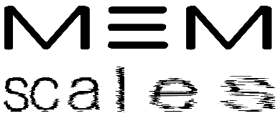 |  | 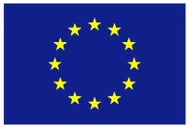
Memory technologies with Multi-Scale time constantS for neuromorphic architectures

Website info | Application domain illustration and typical time scale ranges
Project : | MeM-Scales H2020- 871371 | Start / Duration: | 01/01/2020 /  42 Months
Dissemination: | PU | Nature: | R+O
Due Date : | M13
Filename3: | MeMScales_applic_range_website_Feb21_v0.docx

ABSTRACT:
This report illustrates important target application domains and their representative time scale requirements. It is meant to be placed on the MemScales external website but can also serve other public dissemination purposes.

Deliverable Contributors: | Name | Organisation | Role / Title
Deliverable Leader | Francky Catthoor | IMEC-BE | Member, Senior Fellow
Contributing Author(s) | Giacomo Indiveri | INI-ETHZ | Member, Prof
 | Elisa Vianello | CEA | Coordinator, Edge AI Program Director
Reviewer(s) | Herbert Jaeger | RUG | Member, Prof
 | Giacomo Indiveri | INI-ETHZ | Member, Prof
Final review and approval

Document History:
Release | Date | Reason for Change | Status | Distribution
V0 | Feb.2 | Initial draft |  | Consortium members
V0.1 | Feb.3 | Updates on drone websites |  | Consortium members

TABLE OF CONTENTS
Executive Summary 3

Executive Summary
The project is focused on spiking neural network (SNN) or spiking neuromorphic applications where a diverse range of time scales is present and required. So, we mostly aim at streaming applications where the input/sensor data is samples in a near-continuous stream but where information of the past has to be stored across multiple time horizons.

One major application domain where this is valid is the one of autonomously navigating and moving vehicles like robots, drones and even cars. In that case, use will be made of heterogeneous collection of video cameras, radar sensors and potentially also lidars. Especially due to the recent trend of all those sensors being integrated and strongly miniaturized, a growing interest is present for using them in complex autonomous vehicle applications such as indoor drone navigation [see ETHZ webpage https://eur02.safelinks.protection.outlook.com/?url=http%3A%2F%2Frpg.ifi.uzh.ch%2Fresearch_mav.html&amp;data=04%7C01%7CFrancky.Catthoor%40imec.be%7C20a1f3c17b1845f8b52e08d8c7c431bf%7Ca72d5a7225ee40f09bd1067cb5b770d4%7C0%7C0%7C637478992752105010%7CUnknown%7CTWFpbGZsb3d8eyJWIjoiMC4wLjAwMDAiLCJQIjoiV2luMzIiLCJBTiI6Ik1haWwiLCJXVCI6Mn0%3D%7C3000&amp;sdata=q7qz3gUzTJrtr4RkuAW5zyZvULFDI2SpCA7wT%2BCb3%2FY%3D&amp;reserved=0 and IMEC website www.imec-int.com for nice illustrations of this]. In those novel scenarios, the sensors must perform well in dense scenes with large numbers of neighbouring targets and should allow to separate targets from the background noise and clutter. However, equally essential for the overall navigation capability is the detection algorithm which also requires a recognition module. For that purpose, adaptive spiking neuromorphic systems are a prime candidate. Due to the complexity and time-varying nature of the environment through which the drone has to navigate (as illustrated in figure 1), the SNN has to store information about the past history at different hierarchical time scales in a very wide range.
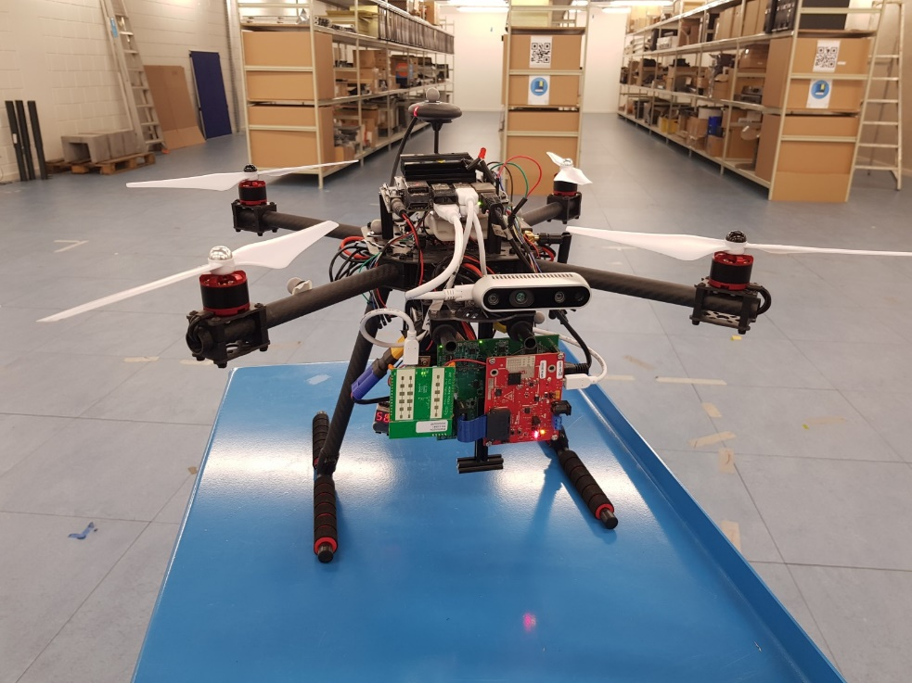
Mini UAV for industrial applications

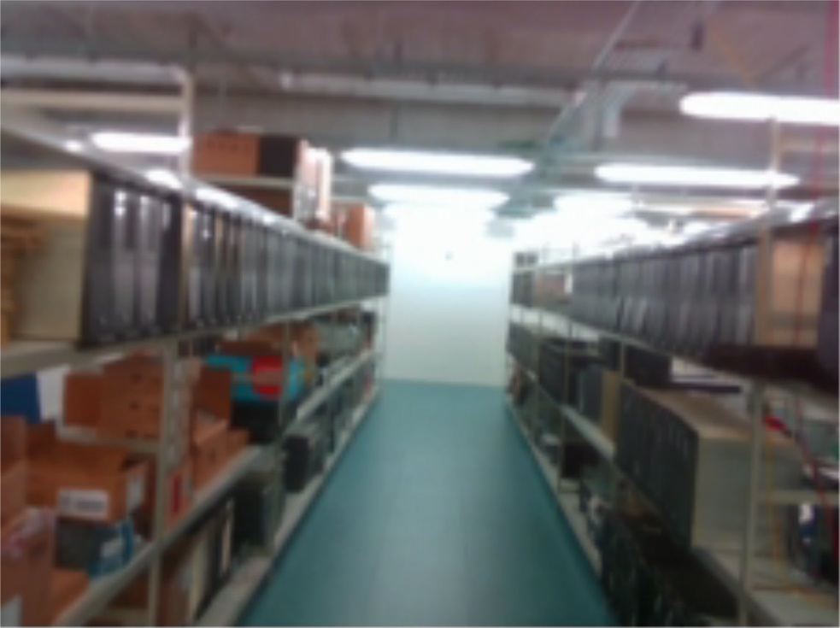
Fig. 1: Illustration of autonomous navigating drone application based on sensors: drone sitting in front of in-door setting (top) and part of route during flight (bottom)

In particular we distinguish at least the following time scales:

- Immediate collision with (very) nearby objects in order to prevent damage to the rotors especially, which has to happen in the range of msec up to a fraction of a second,
- planning the route in between larger objects like the shelves or other flying drones which has to occur in periods of fraction of a second to a minute,
- planning the route ahead to reach the final target while incorporating the terrain and obstacles which have been encountered up to now. This has to occur across periods of minutes to hours depending on the overall flight duration.

Another major application target domain are sensor-based healthcare and life-style systems such as smart patches, smart wristbands, smart glasses and even smart shoes (see figure 2) . Also in that case, use will be made of heterogeneous set of sensors for collecting information such as ECG, EMG, bio-impedance streams and potentially also brain info through EEG sensors and neuro-probes. Especially due to the recent trend of all those sensors being integrated and strongly miniaturized, also here a growing interest is present for using them in complex medical-strength healthcare wearables [see IMEC website www.imec-int.com for illustrations of this].
However also here the needs exists to analyze and interpret the raw data to avoid having to send all this high-throughput data over wireless channels to a central point. We want to first strongly compress those data and only send the relevant subset to the central point such as a mobile from where it can be transferred further into the cloud. So for this purpose we will use at least partly SNNs, which again needs to store and handle information across a wide range of past history.

In particular we distinguish at least the following time scales:

- Immediate state-of-health of the person to prevent overlooking early signs of emerging disease or threats on well-being, which has to happen in the range of msec up to a few seconds,
- Monitoring daily changes across different activities both in the day and the night time which requires periods of seconds to hours,
- Monitoring longer term evolution of the state-of-health and detect anomalies across periods of days to years even.

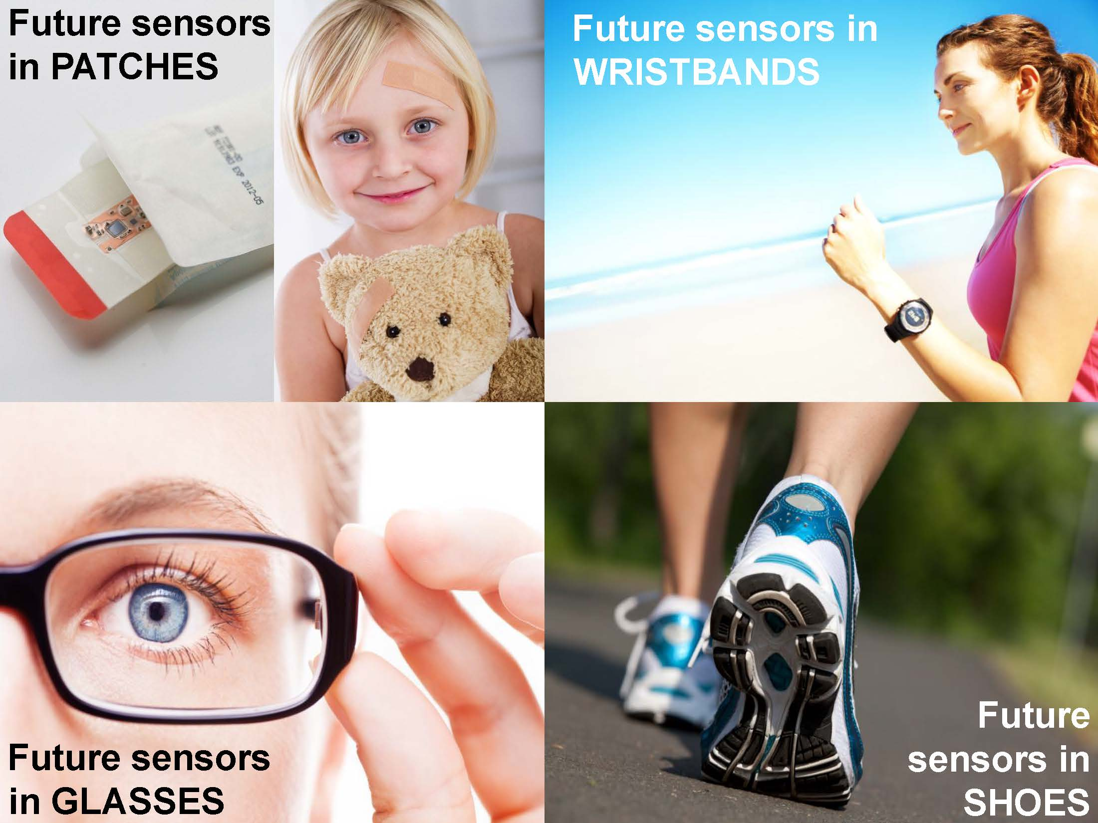
Fig. 2: Illustration of healthcare and life-style applications based on wearables

A table summarising requirements for time scales is provided below.
Purpose | Time scales
Immediate state/threats | msec to second
Planning/monitoring across short periods | seconds to minutes or hours (intra-day)
Tracking evolution over longer periods | days to years

It can be concluded that we need to potentially span up to 9 orders of magnitude from msec up to years.

PU = Public; CO = Confidential, only for members of the Consortium (including the EC services).
R = Report; R+O = Report plus Other. Note: all “O” deliverables must be accompanied by a deliverable report.
eg DX.Y_name to the deliverable_v0xx. v1 corresponds to the final release submitted to the EC.
Person from the lead beneficiary that is responsible for the deliverable.
Person(s) from contributing partners for the deliverable.
Typically person(s) with appropriate expertise to assess the deliverable quality.
Status = “Draft”; “In Review”; “Released”.

